**Logan Commons**

**Preliminary Project Overview**

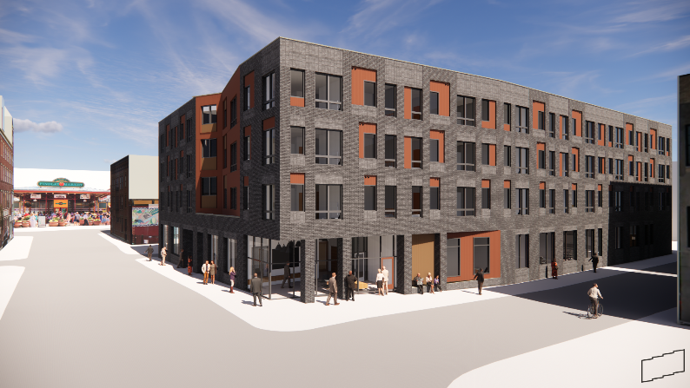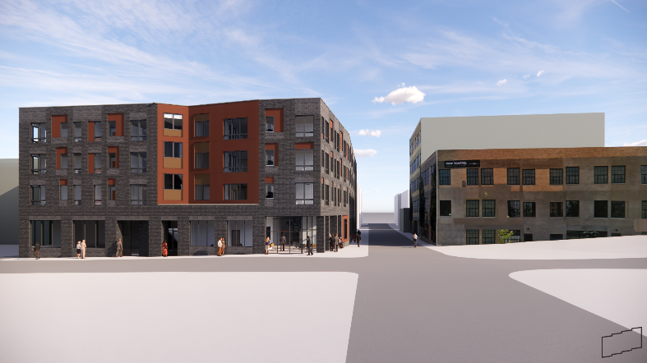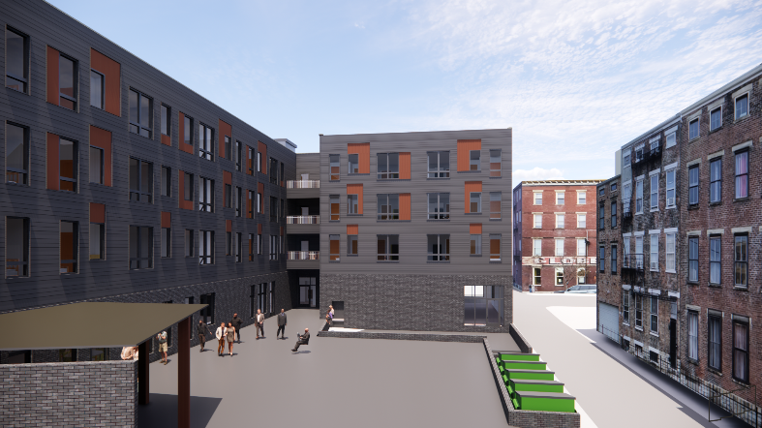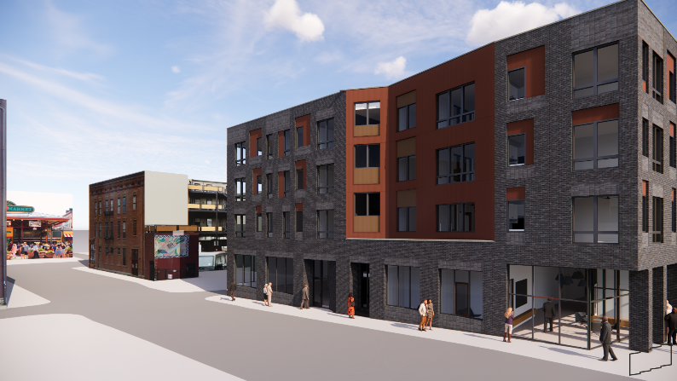

Preliminary Project Overview

Updated November 1, 2022



**Project Narrative**

A unique partnership of Meals on Wheels (MOW), formerly Cincinnati Area Senior Services (CASS), Cincinnati Metropolitan Housing Authority (CMHA), and Urban Sites proposes the construction of Logan Commons, a new building in Over-the-Rhine that will provide much-needed high-quality housing for seniors, as well as a brand-new senior center designed for social service delivery and as a social hub for the community.

The building will offer the following:

* Housing: CMHA will operate three stories of brand-new, high-quality housing designed specifically for seniors’ needs. The design team will take specific care to ensure bathrooms, kitchens, and commons spaces have seniors’ accessibility as a top priority. There will be 38 one bedroom apartments and 4 two bedroom apartments that will be managed by Touchstone Property Services, an affiliate of CMHA. CMHA is the 17th largest housing authority in the United States and consistently receives designation as a high performing agency from the U. S. Department of Housing and Urban Development (HUD).
* Services for Seniors: The first floor of the building will contain the senior center, an approximately 2,000 SF space operated by MOW. Its key feature will be the senior café, a large space that will serve grab-and-go meals for residents and for neighborhood seniors, and provide a space for them to eat and gather. This space will be flexible enough to host events. The senior center will have technology space where seniors can video chat friends and relatives, as well as space for consultation with health care screenings, and meetings with services providers. An approximately 700 SF fitness room will have equipment designed for seniors.
* Outdoor Amenity Space: A courtyard will provide for covered gathering space for family gatherings. A small garden and outdoor games will also be provided.

The programs will be offered by a common staff to ensure they are specific to seniors’ needs.

Project Features:

1. LEED Silver or higher certification for energy efficiency and green building.
2. Proven development team with a strong track record. CMHA and Urban Sites will serve as co-developers. Both organizations have strong experience in delivering affordable and market rate projects on time and under budget.
3. MOW is Cincinnati’s leader in providing services to seniors, serving 4,000 seniors annually.

|  |  |
| --- | --- |
| Project Timeline (Subject to change) |  |
| FHAct 50 Award | Fall 2021 |
| Financial Closing | Spring 2023 |
| Construction Start | Spring 2023 |
| Construction Completion | Summer 2024 |
| Fully Occupied | Summer 2024 |

|  |  |  |  |  |  |  |  |
| --- | --- | --- | --- | --- | --- | --- | --- |
| Proposed Uses (In Progress) | | |  | Proposed Sources (In Progress) | |  |  |
| Acquisition (Land) | $1 | |  | **Bank** | $3,342,000 |  |  |
| Site Improvements | $821,410 | |  | **CMHA Seller Note** | $0 |  |  |
| Hard Costs | $11,818,590 | |  | **CMHA Capital Funds** | $1,159,640 |  |  |
| HC Contingency | $479,365 | |  | **CMHA GP Contribution** | $0 |  |  |
| Professional Fees | $564,000 | |  | **CMHA DDF** | $340,000 |  |  |
| Construction Finance | $442,798 | |  | **City Capital/HOME** | $1,000,000 |  |  |
| Perm Finance | $86,000 | |  | **Equity** | $7,744,000 |  |  |
| Soft Costs | $306,703 | |  |  |  |  |  |
| Reserves | $161,319 | |  |  |  |  |  |
| Dev Fee | $840,000 | |  |  |  |  |  |
| Totals | **$15,520,185** | |  |  | **$13,985,640** |  |  |
|  | |  |  | **Difference** | **($1,934,545)** |  |  |

**Development Team (As of November 1, 2022 subject to change)**

**Land Owner** Cincinnati Metropolitan Housing Authority (CMHA)

**Lead Developer** CMHA

**Property Manager** Touchstone Property Services

**Architect/Engineer** GBBN

**General Contractor** – TBD

**Development Counsel** TBD

**Lender** Cincinnati Development Fund

**Tax Credit Issuer** Ohio Housing Finance Agency

**Syndicator** TBD

**Supportive Service Provider:** Meals on Wheels

**Trustee** TBD